**Internet gateway**

An internet gateway is a horizontally scaled, redundant, and highly available VPC component that allows communication between your VPC and the internet

**VPC and subnet sizing**

* When we create vpc in AWS , the allowed block size is between /16 and /28
* When we create a subnet we cannot use 2 ipaddres
  + All 0’s is network id (x.x.x.0)
  + All 1’s is broad cast ip (x.x.x.255)
* In the case of AWS VPC we cannot use 5 ipaddresses in every subnet
  + All 0’s is network id (x.x.x.0)
  + All 1’s is broad cast ip (x.x.x.255)
  + x.x.x.1 (Reserverd by AWS for VPC Router)
  + x.x.x.2 Reserved by AWS for IP address of the DNS Server
  + x.x.x.3 Reserved for future usage.
* Exercise: Lets Create a VPC with 4 subnets and each subnet should be capable of having 500 devices each.

network cidr: 192.168.0.0/21

subnet1 cidr: 192.168.0.0/23

subnet2 cidr: 192.168.2.0/23

subnet3 cidr: 192.168.4.0/23

subnet4 cidr: 192.168.6.0/23

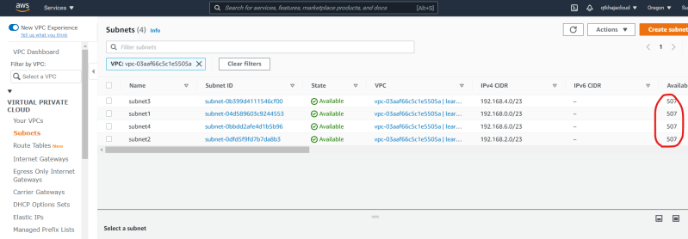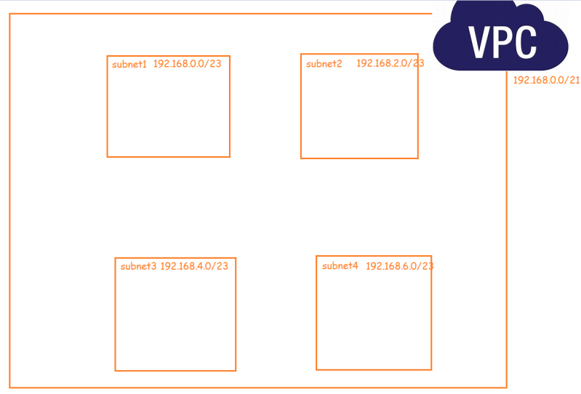

* Now we create vpc because we want to run our resources in this vpc.
* When we run our resources in VPC, we might need to access our resources (vm’s) from internet
* AWS VPC created by us is private in nature by default and cannot be accessed from internet.
* To enable access to our vpc from/to internet, we need to Create an internet gateway 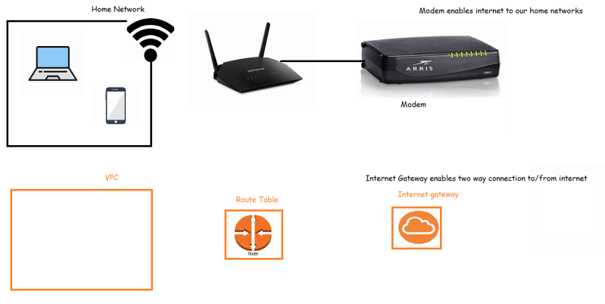
* Create and attach internet gateway to VPC 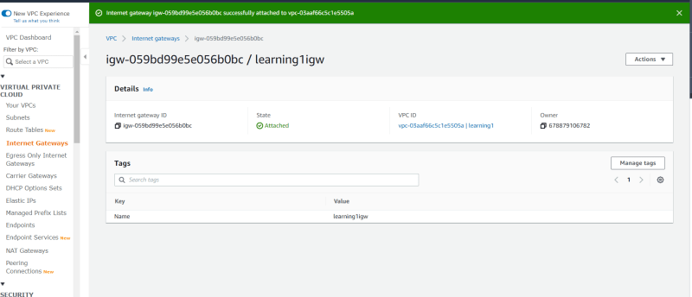
* Select the default route table of the vpc 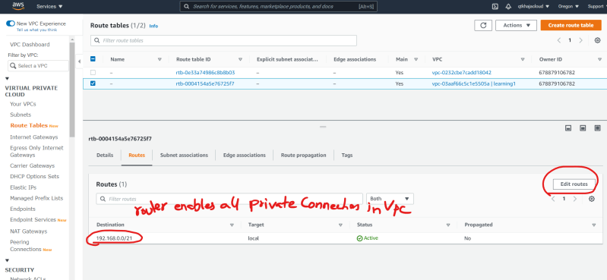
* Now we need to create a route which says, if the packet wants to travel to any ip address apart from vpc range forward to internet gateway

192.168.0.0/16 => 192.168.x.x

192.168.0.0/24 => 192.168.0.x

192.168.0.10/32 => 192.168.0.10 Specific ip address

0.0.0.0/0 => x.x.x.x Any Ip Address

* Now add a route in default route table 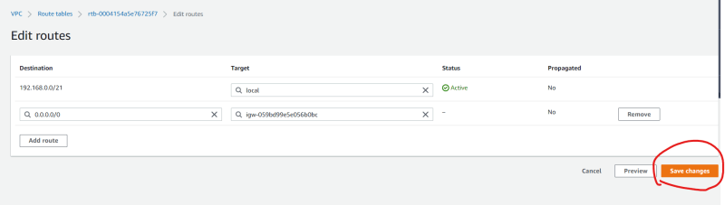
* In AWS by default all the subnets will be forwarding traffic to route table with main as yes 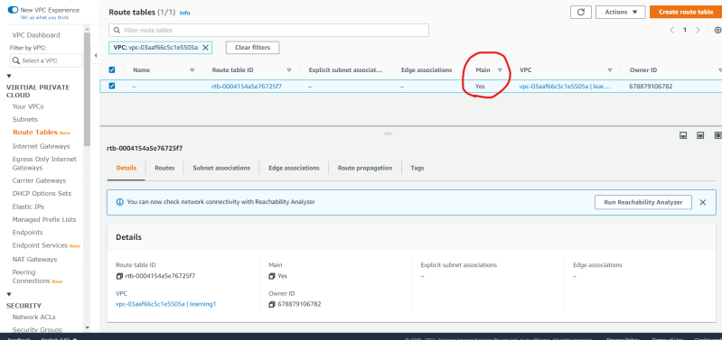
* Now lets try to create an ubuntu ec2 instance in subnet 1 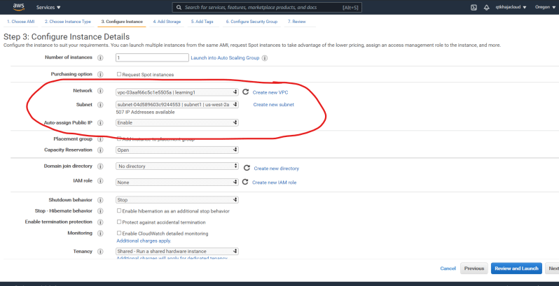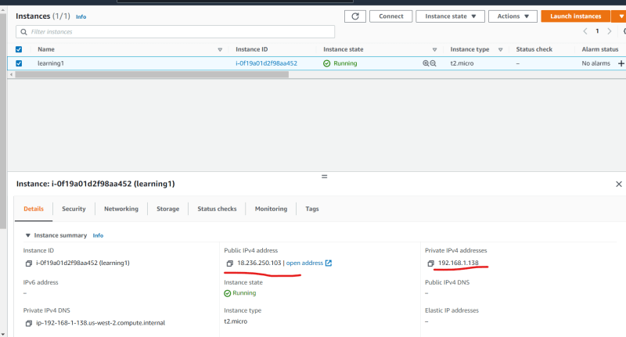
* Now lets try to login into ec2 instance

ssh -i <path to pem file> ubuntu@<puplicip>

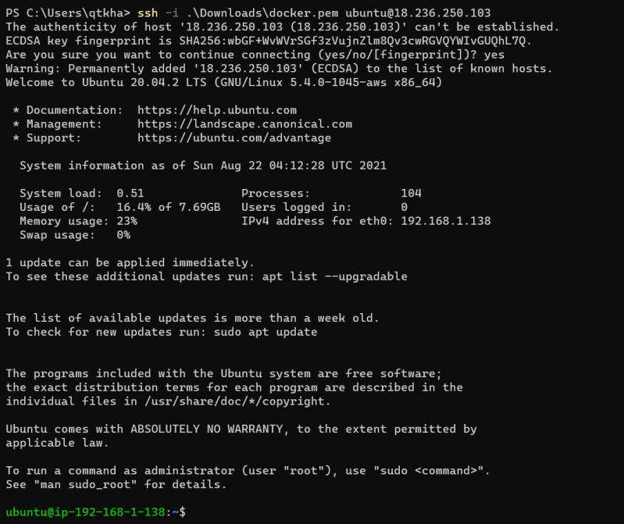

* The stuff which we have done so far 